Uploading HTML file in AWS S3:

1. Go to S3 service
2. Create a bucket
3. Create folder in that bucket
4. Upload html file in that folder
5. Select that file -> go to more -> select Make public (this will make the html file public)
6. Click on the file ->There will be a link option-> go to that link -> Html file will open

Launching instance in AWS:

1. Go to EC2
2. Go to launch
3. Select Amazon Linux AMI
4. Choose t2 Micro
5. Go to next configuration details
6. Add storage

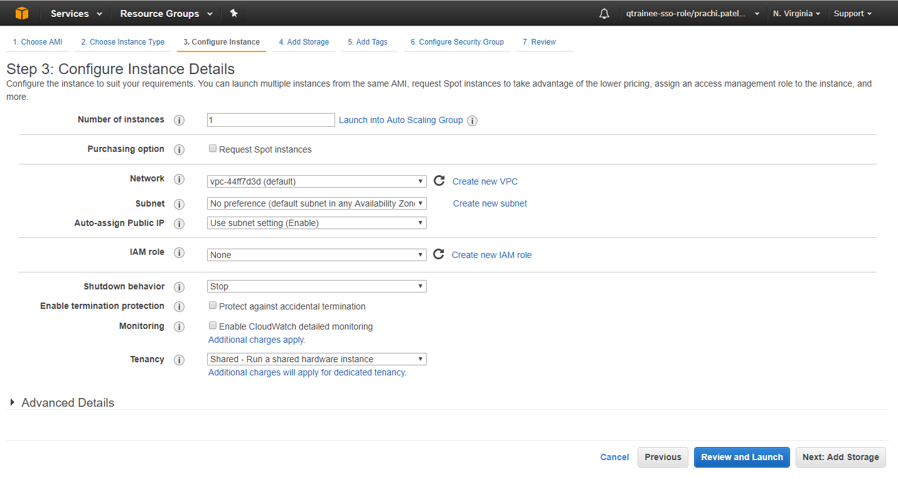

1. Go to add tags
2. Add tag for name,Email_id,Project tag with their values

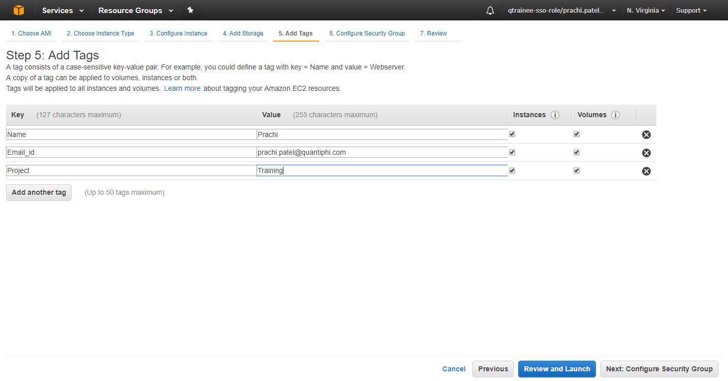

1. Configure Security Group
2. Review and launch
3. Launch

Launching instance in GCP:

1. Go to compute Engine
2. VM instance
3. Select project (Qtraining) ->Continue
4. Create instance
5. Give instance name
6. Select appropriate boot disk
7. Set firewall as per requirement
8. Create

